Project structure: Dags are under ‘./airflow/dags’ folder.

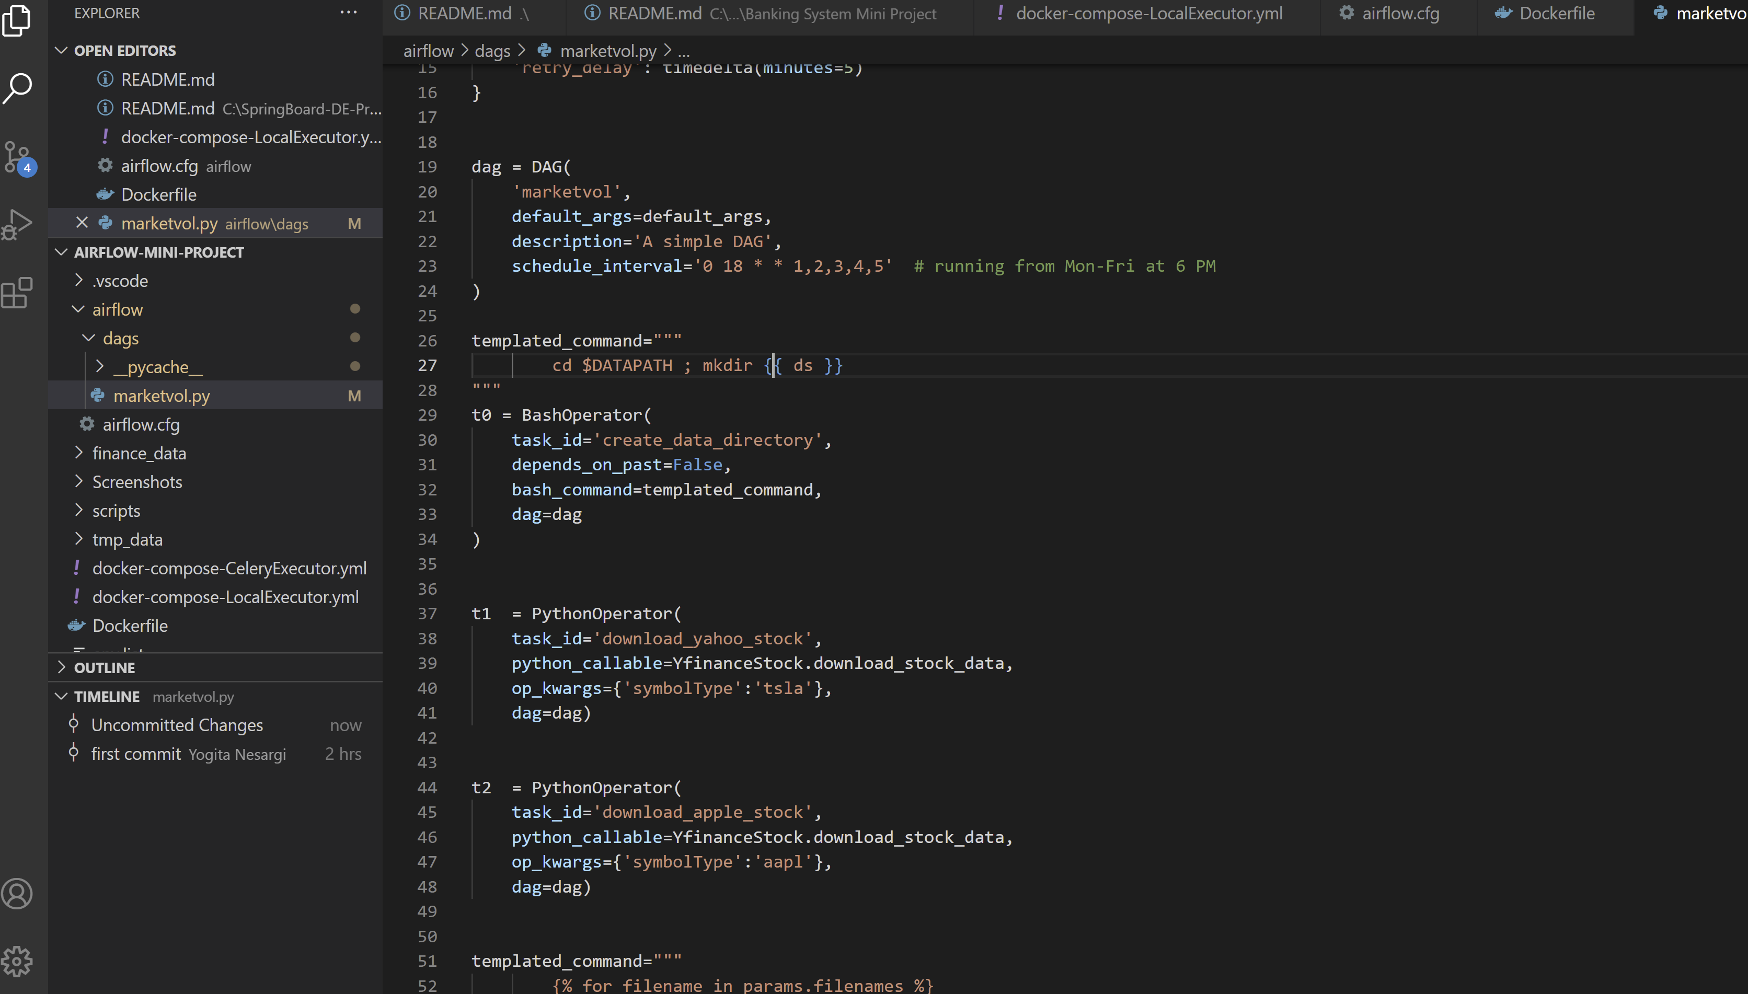

Scripts are under: ‘. /scripts’ folder

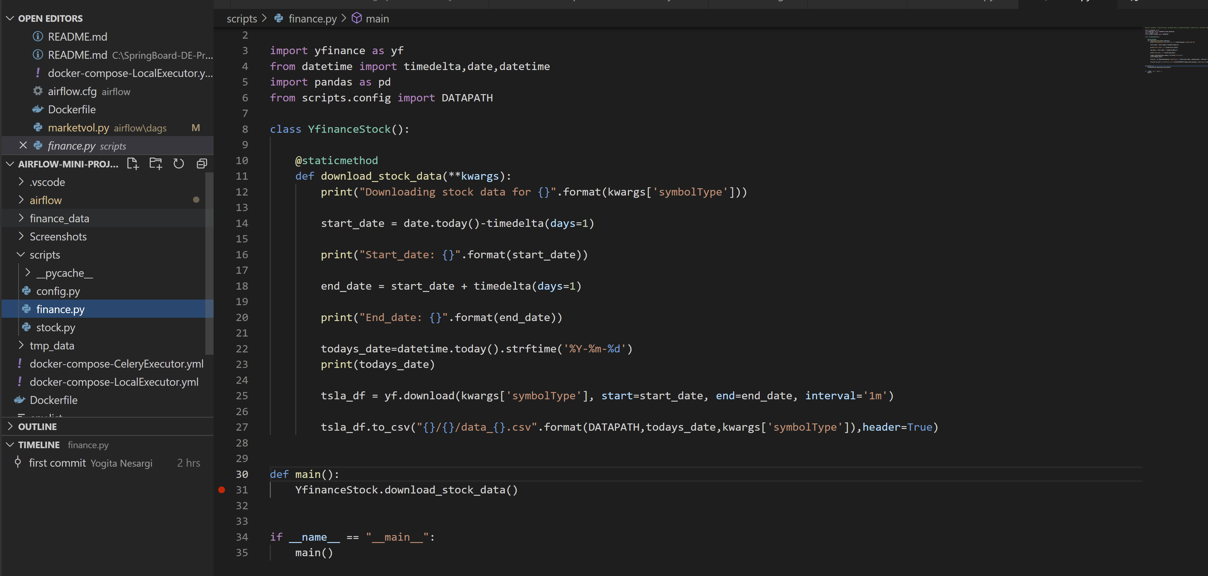

Starting docker container

Command: docker-compose -f docker-compose-LocalExecutor.yml up --build

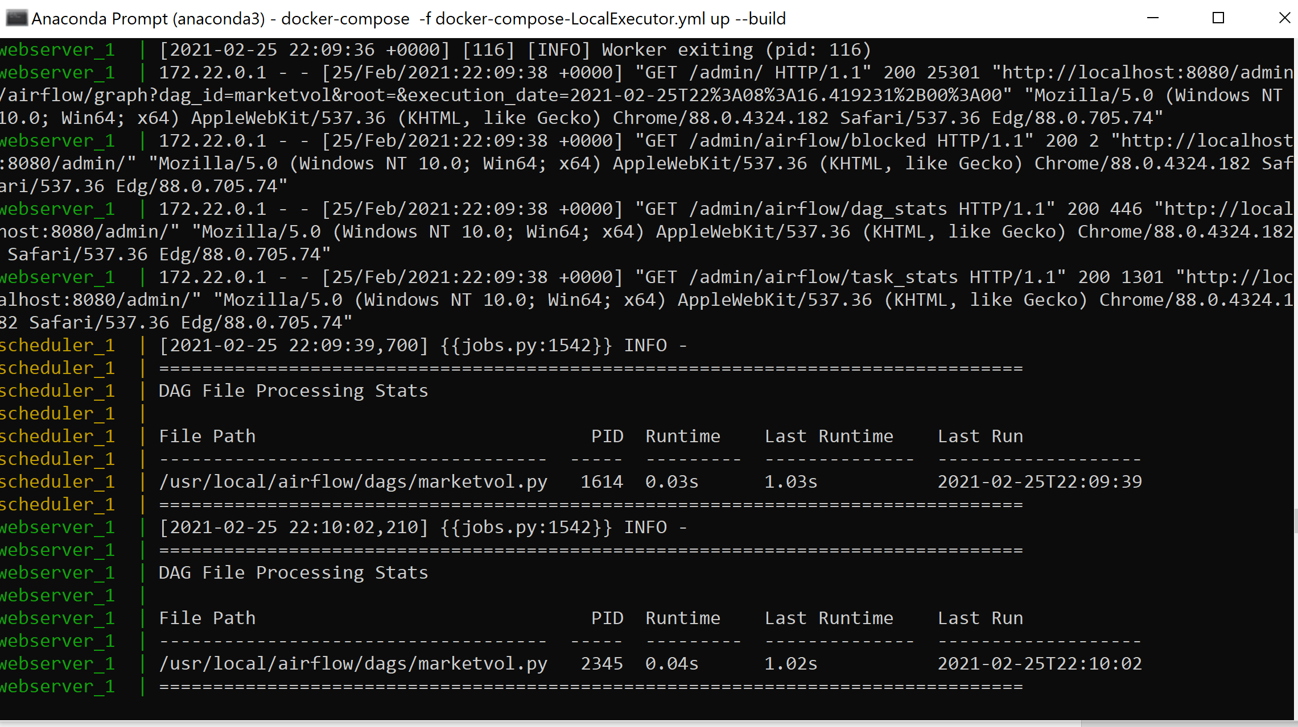

Access Airflow UI using ‘http:localhost:8080’

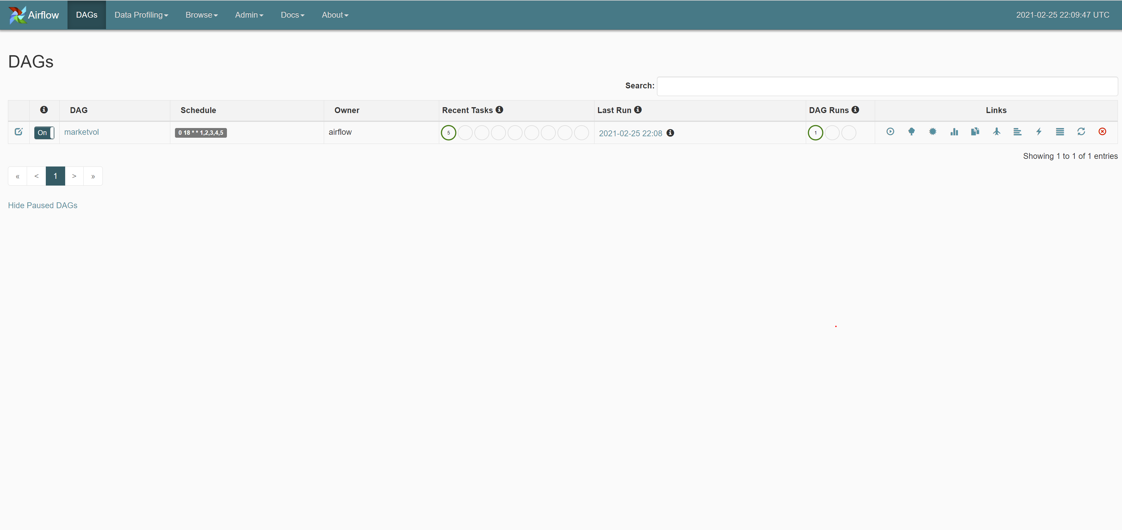

Graph View

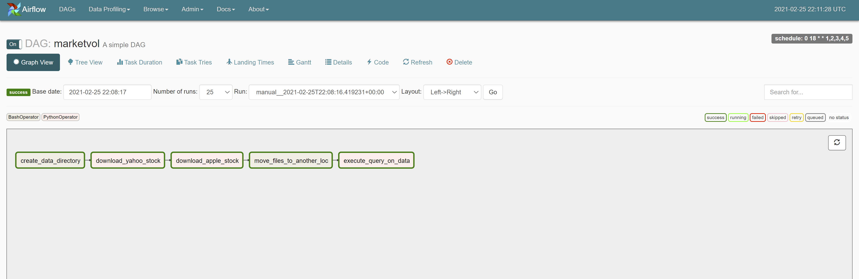

Tree View

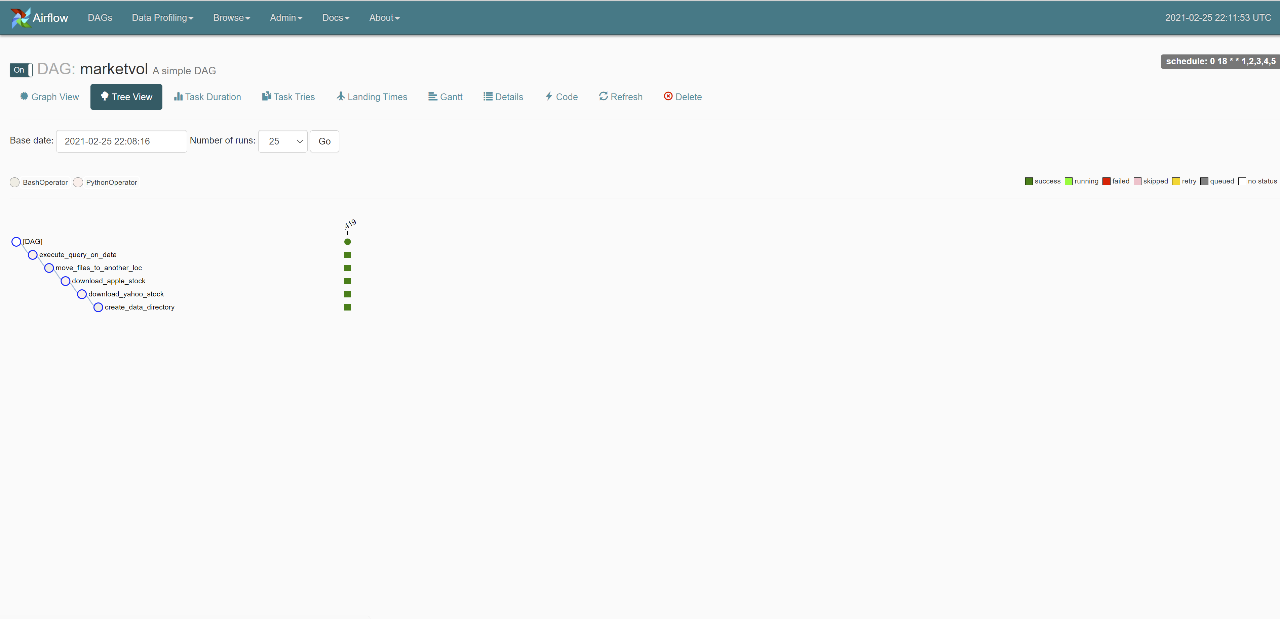

Logs of individual task

Task 1: create_data_directory

Airflow task uses BashOperator to create a directory on current_date: 2021-02-25



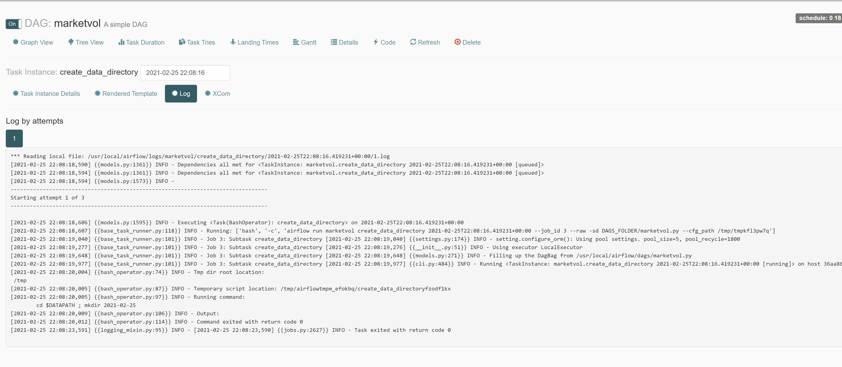

Task 2: PythonOperator to download yahoo stock. Stock data is downloaded to temporary path ‘/usr/local/tmp_data/2021-02-25’

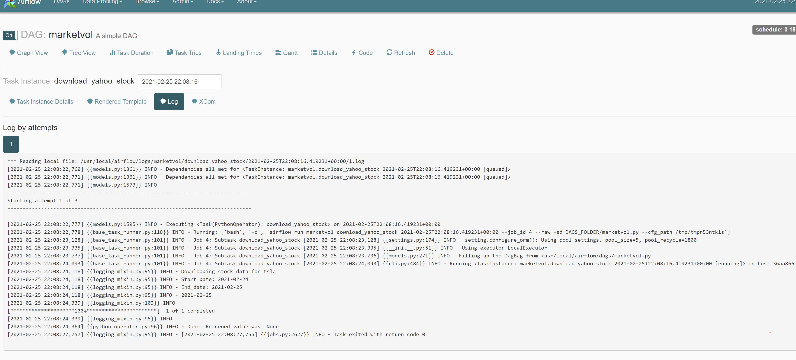

Task 3: PythonOperator to download apple stock. Stock data is downloaded to temporary path ‘/usr/local/tmp_data/2021-02-25’

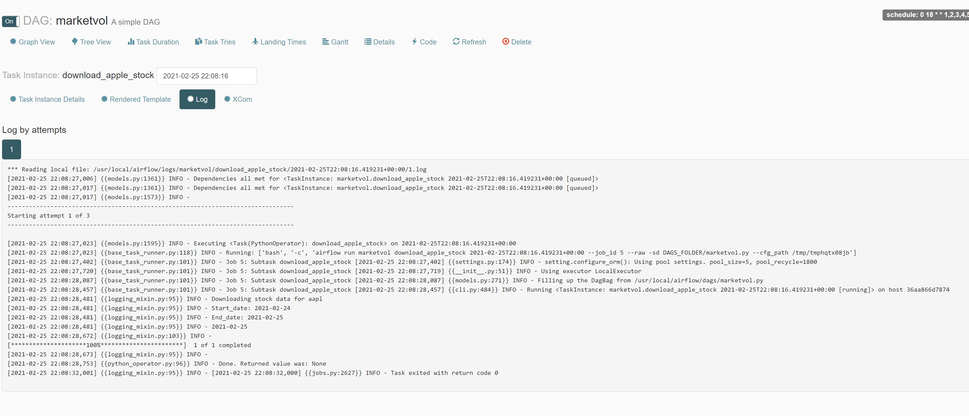

Task 4: Airflow uses BashOperator to move the data from temporary storage to another location ‘/usr/local/finance_data’

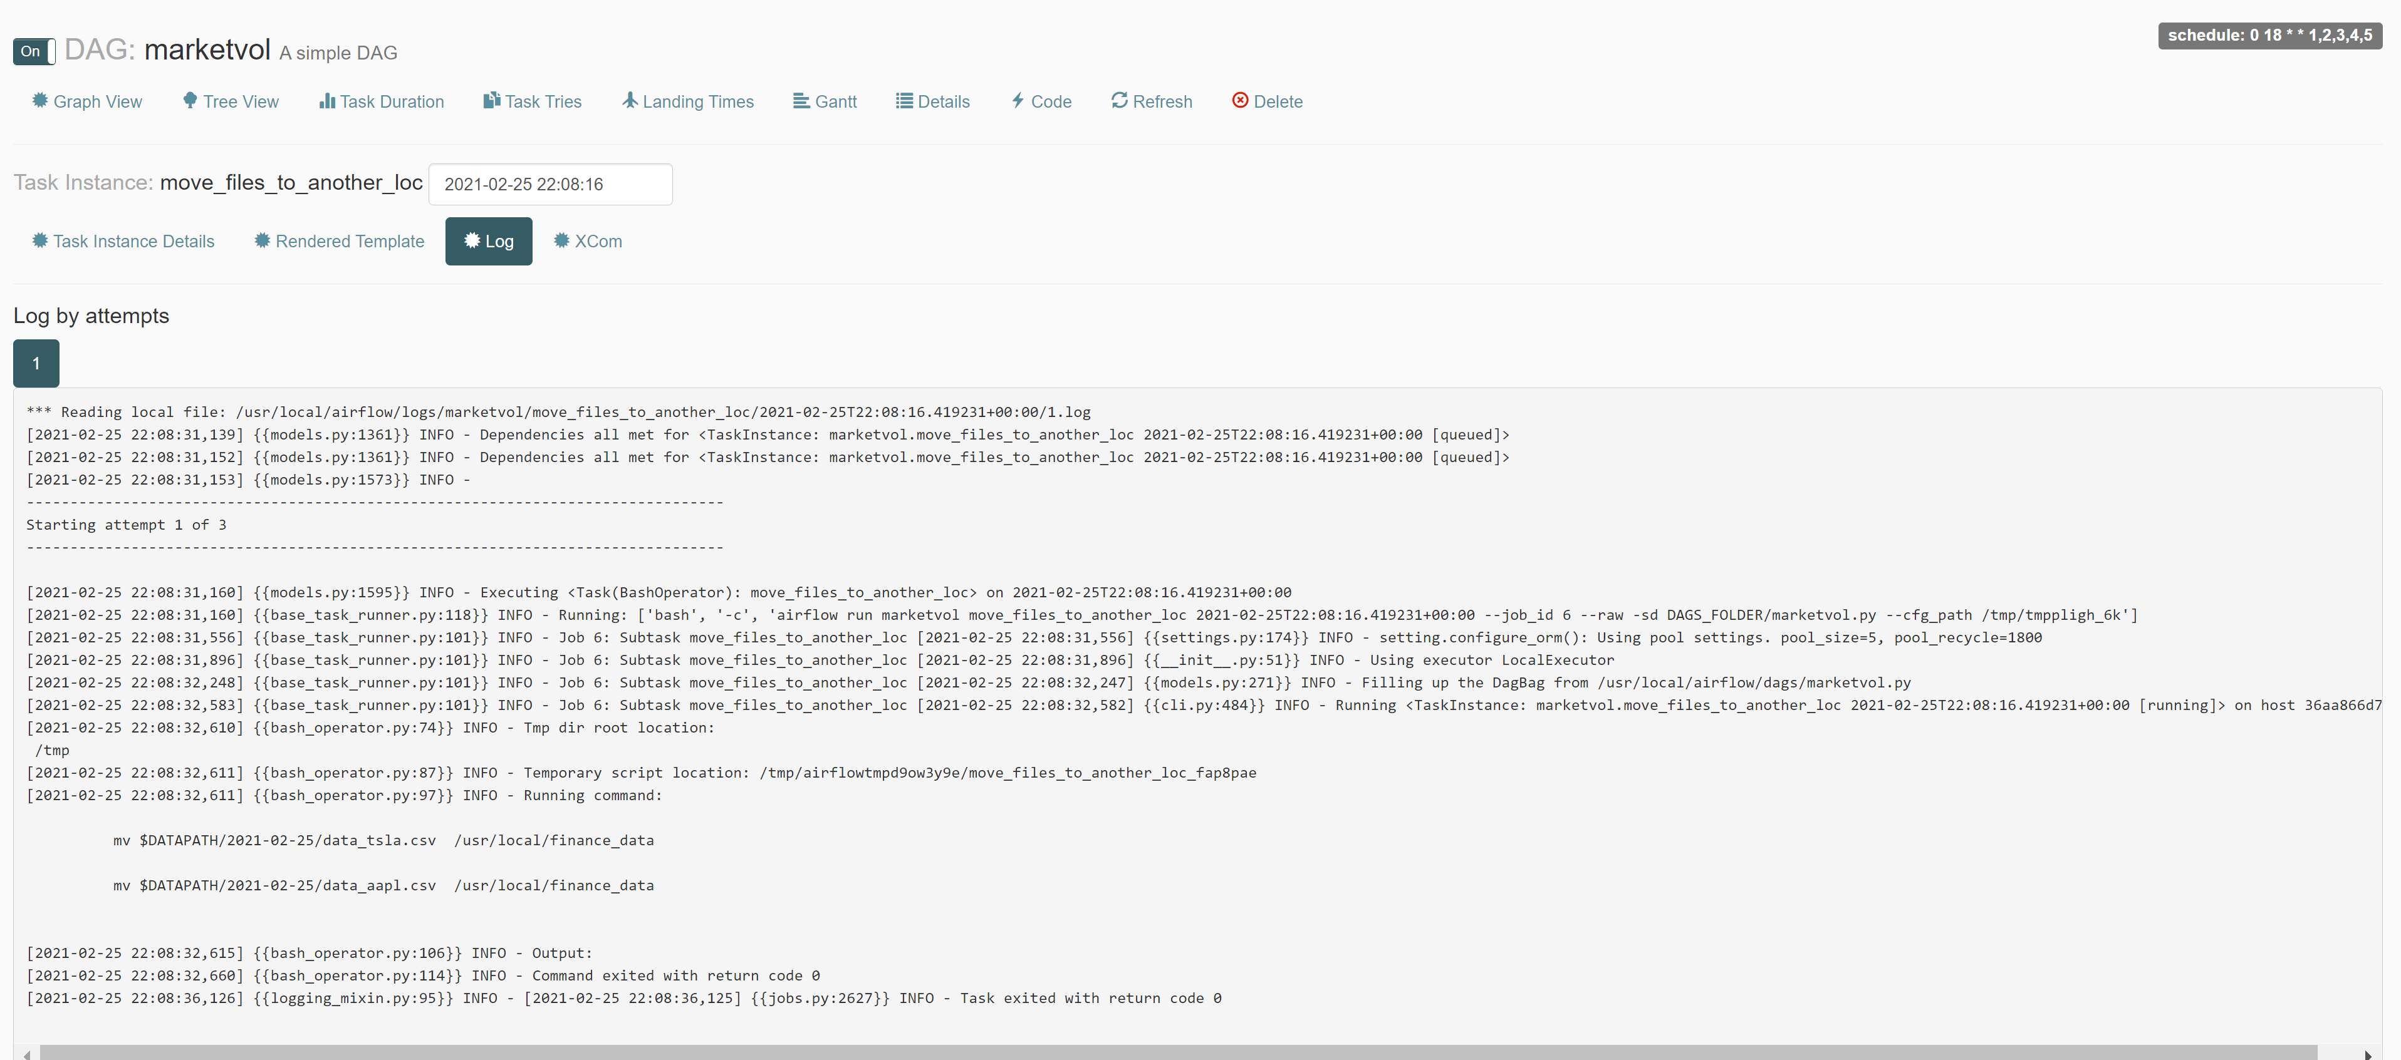



Task 5: Finally, airflow used ‘PythonOperator’ to run query on the above two datasets

